Welcome to the Ancient Art of Wildcrafting

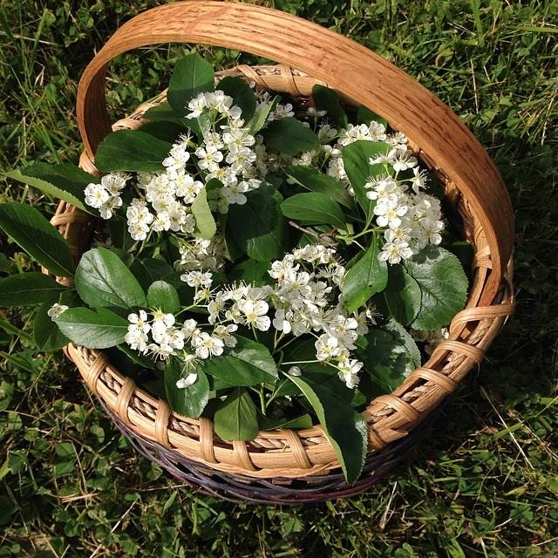
The first and most important rule is: Know, beyond a shadow of a doubt, what you are gathering . To the inexperienced eye, many plants are similar-looking, even on close inspection. It takes time and practice to learn a new plant and, just as importantly, any poisonous look-alikes it may have. This is no time for impatience, or – something I’ve been guilty of myself – talking yourself into an ID because that’s what you want it to be. A good field guide (or several) is a worthwhile investment. Use botanical names; while convenient and sometimes whimsical, common names are notoriously misleading. Once you’ve established what you have, you can begin…

Where to gather
Ok, first, where not to gather. Unfortunately, going into the wild to find herbs isn’t as simple as it once was, especially in settled areas. Obviously, you want to avoid anything growing near a major roadway (especially downhill of one) or an industrial site – current or former. Also be aware of intermittent factors such mosquito sprayings. Even out in the country, consider any adjacent farm fields and what may have been applied to them. Parks sometimes use herbicides for “invasive species control” and even friends and family occasionally treat their lawns. Also be aware of high foot and pet traffic.

Once you’ve skirted around those red flags, look for a healthy ecosystem. The plants should be diverse, plentiful, and strong-looking. Any water should be clean and lacking in weird smells. There should be a comfortable level of wildlife: birds, bees, dragonflies, rabbits, turtles; whatever is normal for the area. Last but not least, be certain that the population(s) of plant(s) you want to take are strong and will not by harmed by your gathering.

When you find a good spot, make sure that you have permission to harvest; most people won’t mind you taking their weeds!

When to gather
This depends on what you’re after. You want to harvest when the energy is at its peak concentration in the part you’re gathering. Generally, it goes something like this:

- Bark: spring or fall, when the sap is running.
- Leaves: spring to early summer, when they are fresh and undamaged but mature.
- Flowers: spring to late summer, depending on bloom time, just as they begin to open.
- Roots: late fall to early spring, when nutrients are stored there for the winter.
- Seeds and fruits: late summer to early fall, just as or just before they reach maturity.

The ideal time to harvest is on a clear, dry day in the late morning just after the dew has dried and before the plants have been wilted by heat or sun. But as a teacher of mine once said, there’s the best time to gather, and then there’s real life. If you can hit any or all of these ideals: great. If you can’t, don’t worry, just do the best you can. The plants are forgiving. There are, however, a few rules that I stick to:

- Plant material should be dry. Dew, rain, or even high humidity can cause mold and/or dilution of your preparations.
- The weather should feel good. If it’s exhaustingly hot or you feel like you’re trying to breathe underwater, the plants will be stressed as well.
- Avoid harvesting on cloudy days, especially flowers. Many herbs are sun-loving and go semi-dormant when it’s overcast.
- Observe the plants. You want them to be upright and vibrant looking. If they seem wilted, dried out, or otherwise stressed, it is not a good time for gathering. Likewise, don’t harvest when you are stressed out, ill, or angry. That energy will come through.

How to gather
Gently. Respectfully. As with most things, it will be most enjoyable and successful when done with mindfulness and appreciation. Remember that we are entering into a partnership with the herbs for our mutual well-being. While it’s an unfamiliar (and perhaps uncomfortable) practice for many of us starting out, I believe it is important make a connection with the plant before harvesting. Take a moment to sit quietly and reach out to it, asking permission to gather and offering gratitude for its medicine. This needn’t take the form of words; if you focus your thoughts and engage your heart in that direction, you’re on the right track.

It’s a delicate ecosystem out there, and it’s vitally important that we care for the plant populations we depend on. It’s commonly agreed to take no more than 10% of any particular type of plant in an area. If you’re harvesting above-ground parts, use sharp clippers and leave enough of the plant intact that it can regenerate easily. Always leave enough flowers/seeds to allow the population to grow. Scatter some around if you can. This mentality is doubly important when harvesting roots. If all you need is the root itself, it’s good to replant the crown. If rhizomes will serve your needs, leave the root itself in place. If you are taking the whole plant, just be sure not to over-harvest, and disturb the soil around the remaining plants as little as possible.

I prefer cotton/canvas bags, baskets or paper grocery bags for putting herbs in as I gather. Baskets won’t close up or tip over on you, but bags are easier to carry around; it’s really just personal preference. You want the herbs to be able to breathe a bit, but also, if you’ll be out for a while, you want them to be protected from the sun. In no case do you want to use plastic. I recommend shaking off as many insects as possible as you go.

What now?
So you’ve done everything right, and have a beautiful bounty of herbs. The first thing to do is get them out of those bags or baskets. If possible, go straight home; you don’t want them sitting in a hot car. Once there, either process them, eat them, or at least spread them out a bit right away. Try to garble them within 24 hours (garble: sort through and discard any dead leaves, bugs, discolored spots, etc. – anything you don’t want in your finished products). A good general-purpose approach is simply to dry them. If the weather is nice, I like to do this by spreading them out on screens somewhere shady and well-ventilated until they turn crispy. If it’s humid, a dehydrator set to about 95˚F works well. Once dry, pack them into clean containers; I prefer glass, while some herbalists double-bag in paper. For other things to do with them, see the Basic Preparations handout.

