Violet
Viola spp.

There are many species of violet native to North America, but fortunately for us, they can all be used more or less interchangeably. The species you are likely to see in herb books is V. odorata, which has a lovely fragrance and makes a delightful syrup. Around here, we mostly have V. sororia, or the common blue violet, which has far less of the aromatic constituents, but is powerful medicine nonetheless. Despite its name, the spring flowers can range from white through pale purple and blue to the deep violet we would expect. You’ll even find yellow ones here and there. Interestingly, these spring flowers are not reproductive and therefore serve no biological function.

The reproductive flowers appear in the fall and are an inconspicuous green. Mainly for this reason, the spring blooms have been considered purely an expression of joy and a celebration of returning life, giving the plant use as food and medicine on a spiritual level, to gladden the heart and banish despair.

The leaves and flowers are, physically, very similar in action, but it’s the leaves that are usually mentioned because they’re so much more practical to collect and use. The largest part of violet’s therapeutic value lies in its mucilage. Chew on a fresh leaf and you’ll notice it immediately. This demulcent (soothing, moistening, healing) quality comes in very handy for treating inflammation and irritated tissues, such as sore throats or dry eyes.* Like many (but not all) demulcents, it’s gently cooling. Violet also acts as a soothing expectorant, helping to loosen mucus from the lungs and relieve dry, unproductive coughs. It’s useful as a nasal rinse for tight, inflamed sinuses.

Some technical references make a point of the salicylic acid content of violets, the same chemical found in willow and wintergreen. However, it contains fairly low levels of this, and while it may be a good herb to choose as part of a pain-relieving formula, depending on the other properties you want, it’s not used that way on its own. Culpepper states that violets “easeth pains in the head caused through want of sleep,” but I would guess that such relief comes from its overall soothing nature and its much-valued ability to relieve stagnation.

The other, perhaps more notable, thing that violet is known for is its affinity for the lymphatic system. Herbals going back hundreds of years tout violet’s ability to “dissolve hardnesses” and even treat cancer. Certainly it helps to break up congestion and reduce swelling in the lymph nodes, which in turn helps our immune system to function better. This is often done by use of an oil or salve applied topically and massaged in – the massage action is also important for getting the lymph channels flowing - though the tea will be helpful (and delicious) as well. Specific applications for this include glands that get hot and swollen during illness – particularly tonsillitis – and fibrocystic breast conditions.

Violet is pleasant and effective as a tea, tincture, oil, salve, syrup, or infused vinegar. For all its usefulness, it is a gentle herb that can be freely experimented with. The only thing to note is that if you eat a large quantity of leaves, you may notice a laxative effect. You can candy the flowers or add them, along with the leaves, to a salad. They are high in vitamins A and C.

Many people, myself included, are of the opinion that violet doesn’t dry and store particularly well. It may still make a tasty beverage, but most of the medicine is lost. So I recommend gathering it in the spring, and extracting it in any way you choose to last you through the year, and meanwhile munch on it freely.

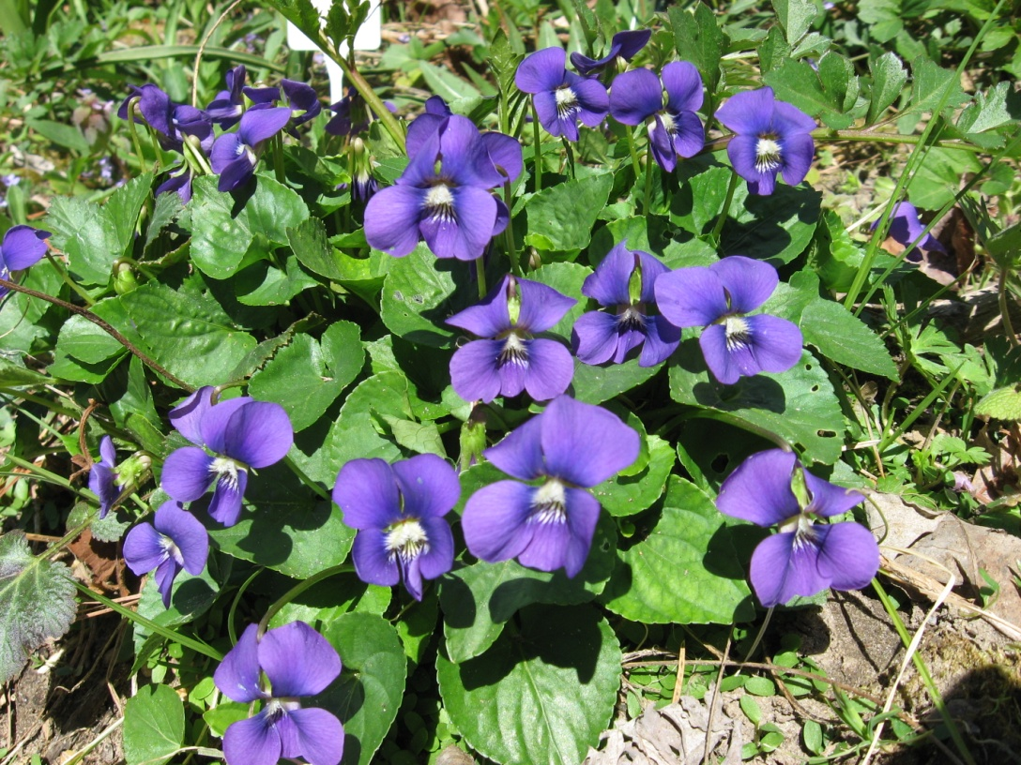

*To make an eyewash or nasal rinse (with any herb), brew a tea – in the case of the gentle violet it can be as strong as you like, within reason, but go easier on things like rose – and strain it well through a coffee filter. To eight ounces (1 cup) of this, add ¼ tsp. salt and mix until dissolved. Let cool to a comfortable temperature.

