Dandelion
Taraxacum officinale

The common dandelion is one of the most useful and generous plants in our region. The botanical name translates from the Greek as “remedy for disorders,” a testament to its widespread usage by ancient physicians. Leaves, roots, and flowers offer us both food and medicine. Even the stem is used by some. And dandelion, of course, loves us and follows us everywhere. It was initially imported to North America as a garden vegetable by European colonists, who recognized its many virtues. The rest, as they say, is history.

The root is an excellent alterative, which means that it supports and enhances the function of the liver, aiding in both digestion and detoxification of the bloodstream. It further acts as a powerful restorative tonic not only for the liver (even in cases of cirrhosis and hepatitis), but the gall bladder and lower GI tract as well. Hand in hand with this is its role as a digestive bitter. As such, it helps to balance stomach acid, bile, and other secretions, and coordinate the function of various digestive organs. Like most roots, it contains inulin, a starch that acts as a prebiotic – food for the beneficial organisms living inside our gut. All of this results in improved metabolism, better absorption of nutrients, and more efficient clearance of waste products. It also acts as a mild diuretic, though this effect is more pronounced in the leaves. The overall effect is remarkably tonic and rejuvenating. One cautionary note: because it stimulates the release of bile, it should not be used where there are stones with a chance of obstructing the gall ducts. On the other hand, regular use of bitters may help to prevent the formation of such stones in the first place.

These effects are long-lasting but also somewhat slow to manifest; you’re not going to take it for an acute situation. For this reason, while dandelion root is fine as a tincture, I prefer to incorporate it into my food. The root can be chopped up and added to stir fries and soups, or dried to make a reasonably tasty tea – yes, it’s mildly bitter, but also a bit sweet, and remember that bitter is a good thing. It can be dried, powdered, and added to oatmeal, yogurt, nut butters, and the like. Roasted, it makes a rich, delicious beverage. It may also be tinctured (the inulin will settle out, be sure to shake it up and keep it in the final product) and taken plain or incorporated into a bitters blend.

The leaves have earned recognition as an effective potassium-sparing diuretic, helping the kidneys to clear what the liver has filtered out. In England, the plant is sometimes called piss-a-bed and employed in cases of children’s bed-wetting. It can be used to treat edema or high blood pressure, but in such cases the underlying cause, of course, must also be addressed. They are also packed with nutrition. In addition to potassium, they’re a rich source of vitamins A, C, E, and K, niacin, magnesium, calcium (far more than milk), iron, and choline. They also work nicely as a digestive bitter, either on their own or in a salad with other greens. They dry nicely, and their effects are well delivered as a tea or tincture.

The sweet flowers can be picked and eaten raw; the calyx is quite bitter and, as beneficial as that is, I feel that the flowers are more of a “treat,” so I usually don’t eat it. The petals themselves are in fact beneficial, containing carotenoids, flavonoids and several other powerful antioxidants that have been shown to help protect against skin cancer. This seems fitting, as dandelion flowers are in such accord with the sun. They’re considered to be brightening to the spirits; as a teacher of mine once said, “You can’t look at a dandelion and be in a bad mood. It’s physically impossible.”

Petals can be added liberally to salads, pancake batter, and anything else that strikes your fancy. Or, if you’re feeling adventurous, you can make a fine wine from them. The unopened buds can be pickled for a lovely sweet-and-sour side dish. Flowers may also be infused in oil to be used topically for sore muscles and dispersing lymphatic congestion, such as that associated with fibrocystic breasts. If you can’t think of enough uses for them all, they do freeze well, and make quite a nice addition to winter meals.

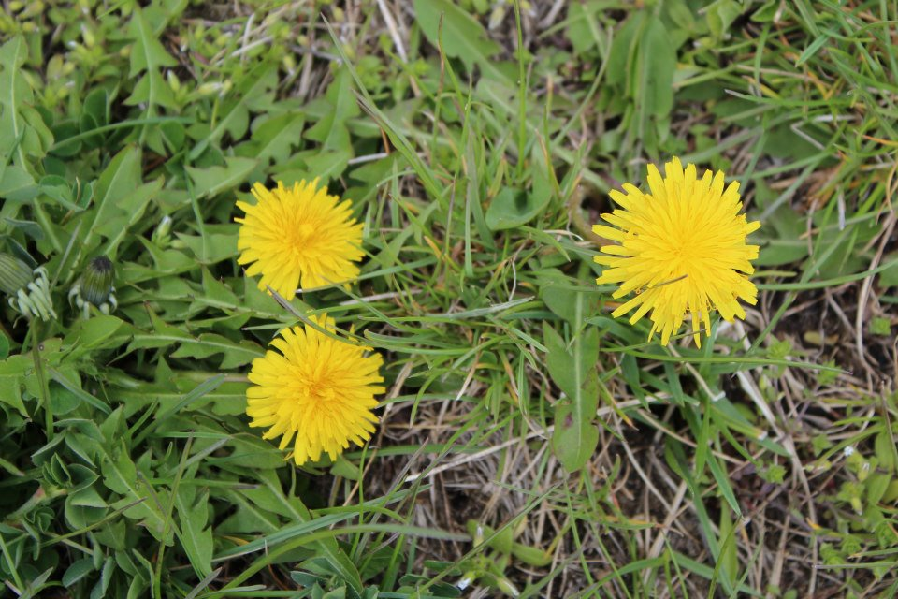
The stems have occasionally been used as noodles, by boiling them in several changes of water. The milky sap (which I don’t recommend ingesting), applied frequently and with diligence, is a folk cure for warts.

