Plantain
Plantago major, P. lanceolata

Few herbs are as humble and helpful as plantain. There are two types that grow in this area that, though they look markedly different, can be used interchangeably. Broadleaf plantain tends to grow on compacted, disturbed soil, which puts it more commonly in our sight. Narrowleaf plantain prefers fields and meadows amongst other plants.

This is the archetypal first aid herb. Its main distinguishing feature is its incredible drawing ability, which has earned it employment and accolades in treating everything from splinters to blood poisoning. I find this is a great plant to get kids (or anyone) interested in herbs – a leaf mashed or chewed up and pressed onto a mosquito bite for a few minutes, or rubbed on until the skin turns green, will often stop the itching and clear the bite by the next day. It’s likewise greatly helpful in treating all manner of bites, stings, and boils. It has the ability to gently encourage tissue growth and repair, which makes it ideal for treating injuries that are infected or in danger of becoming so, such as dirt-filled scrapes or puncture wounds: It will draw out any contaminants while speeding healing. Combined with jewelweed, it’s useful in relieving poison ivy rashes.

In addition to being drawing, plantain has antibacterial activity, specifically against staphylococcus, so it’s a good idea to take it internally as well as topically for infections. One thing you’ll notice is that this is a mucilaginous plant, and also mildly astringent, which gives it a wide range of uses as well. Taken as a tea (usually in formula with other herbs), it’s soothing and toning to the digestive tract – think ulcers, diarrhea, or IBS. While it doesn’t have a particular affinity for the urinary tract by itself, it makes an excellent addition to formulas to address inflammation or infection of those tissues, especially where there is a burning sensation. Plantain has been used time out of mind to treat dry, irritable coughs with an itchy or tickling sensation in the throat, including that caused by sinus drainage. It’s also extremely useful when there has been inhalation of fine particulates, as it will both soothe the respiratory tissues and draw out the dust.

The tea makes a good nasal rinse as well, again for general irritation or dryness. Simply add ¼ tsp. of salt (make sure there are no added fillers in your salt) to an 8 oz. cup of plantain tea, strain through a coffee filter, and put into a neti pot or nasal spray bottle. This solution can also be used as an eyewash for conjunctivitis or irritated corneas.

The leaves can be eaten, and are in fact very nutritious. Simply chewing the leaves is helpful for irritated gums and sore throats; for this, it’s most useful to chew a few times and then keep the wad in your cheek for a while. It’s not the best-tasting herb, and the strong, elastic veins are a bit unappetizing, but chopped well it makes a good addition to salads. The seeds are also rich in mucilage and have historically been used as a bulk laxative, similar to the related Plantago psyllium (the main component of Metamucil).

Plantain holds much of its medicinal value in the mucilage of its leaves, and doesn’t take well to drying or long storage. I have used it dried, and it will do in a pinch, but fresh is definitely better. Fortunately, it’s a hardy plant and even here, it can be found some 8 or 9 months of the year. Still, I like to harvest it during the summer and prepare a tincture, oil (it’s a powerful addition to healing salves), and infused vinegar.
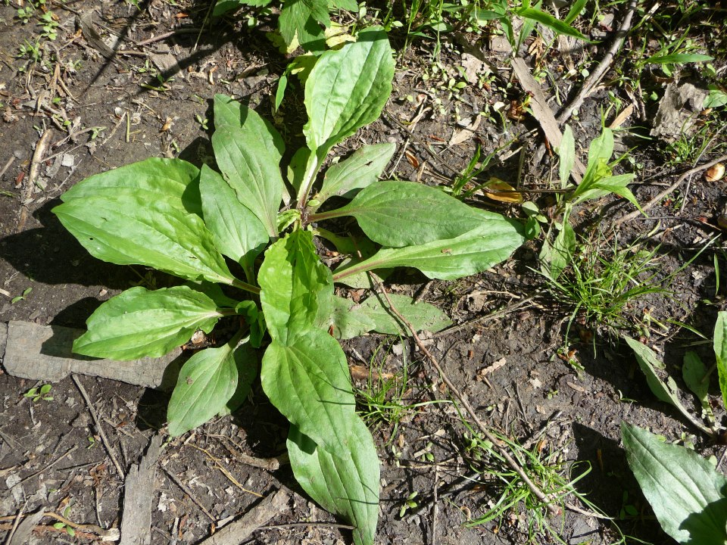

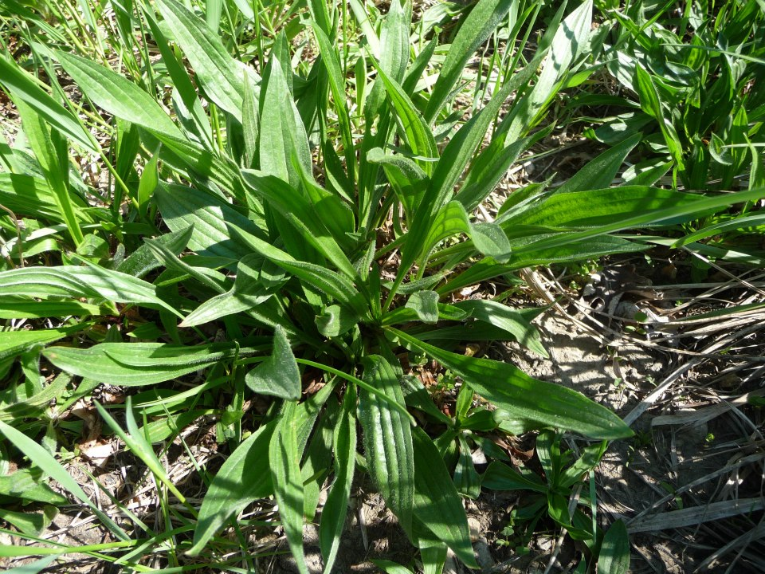
broadleaf plantain

narrowleaf plantain

