Basic Preparations

There are many, many ways to prepare herbs for use. Some of the most common are described in detail below, but here are a few guidelines that apply to everything you make:

- I find it’s helpful to keep a notebook describing your creations. Record the exact ingredients, date(s) (date started and the date strained/bottled where applicable), method, and dosage where appropriate. Also write down how it turned out – taste, color, etc. - how well it worked (or didn’t), any difficulties or surprises you encountered, and what you might do differently next time. I know, this can be tedious, but these notes will be invaluable next time you make something.

- Label everything as soon as you make it. I know you’re smart people who are devoted to your herbalism, but I promise, after a few weeks, you will forget just when you started that oil and, perhaps, exactly which green leafy thing is in that mason jar. Labels should include, at the least, a name and date. If you don’t keep a notebook, include the ingredients as well.

- Both materials and finished products should be stored somewhere cool and dark; definitely out of direct light and away from concentrated heat sources (e.g. not in the cabinet above your stove!). A place that’s dry as well would be ideal, but it can be difficult to meet all 3 requirements. As long as your containers are well-sealed, I think humidity is a minor concern. Small amounts, such as a tin of tea mix or a 1 ounce bottle of tincture, can be kept anywhere and probably be used up before they deteriorate, but larger amounts should be treated more carefully. I keep mine on shelves in the basement.

- While there are a few herbs that, even in whole form, are extremely potent and must be used in small doses, none of the plants we’ll be discussing – indeed none that I use – fall into that category. The vast majority of herbs are gentle (not to be confused with weak) and very forgiving. It can be intimidating working with new things in new ways, especially when we begin with the understanding that they affect our health, but don’t be afraid. Be responsible, of course: follow the guidelines, be aware of possible allergic reactions, and start small, but if you’re off by a spoonful here or a few drops there, nothing terrible will happen. Experiment, explore, have fun!

- Create with mindfulness and joy. The energy and intent that you put into your preparations have a very real effect on the final product.

Tea
While there’s a lot to be said for fresh herbs in terms of potency, when it comes to making tea, dried is usually better. The drying process partially breaks down cell walls in the plant, which helps the flavor and constituents to be extracted. I usually use a kitchen spoonful (maybe half a measuring-type tablespoon) per cup of water. For an infusion, generally used with delicate parts such as flowers and leaves (and some aromatic or delicate roots), bring the water to a boil and pour it over the herb, cover and let steep 15-20 minutes, then strain out and drink. I generally use mason jars or a coffee press and make a quart or so at a time. For a decoction, useful in extracting most barks and roots, cover the herbs with the cold water in a saucepan, bring to a boil, and simmer for 10-15 minutes. If you have the time, solar and lunar infusions are also worth exploring. Teas will keep for a few days in the refrigerator. Of course, details vary depending on which herbs you use, what you want to get out of them, and how strong you like your tea, but it’s hard to go too far wrong with this method.

Tincture
Tinctures are probably the most popular form of herbs to be used as “medicine” in the modern Western sense. They are portable, easy to administer, have a long shelf life, and make their way into the bloodstream quickly. While I certainly advocate supportive, nutritive health, acute situations do arise and tinctures are very useful to have on hand. They are also a good introduction to plant medicine for people who are still most comfortable with the allopathic model.

There are several ways of doing this, but we’ll stick to the simplest: the Folk Method. For this, you simply put your herb(s) in a jar and add alcohol until the plant matter is covered by about an inch, then let it sit for a month or so, shaking daily (or as often as you remember).
For dried herbs, 80-proof (40% alcohol) vodka or brandy works well in most cases. If your herbs are fresh, I suggest letting them wilt for a few hours before packing the jar, then use 100-proof vodka. If you use very fresh plant matter, especially things with a high water content, 151-proof grain alcohol is your safest bet. The closest place to get this is Michigan. Many herbalists recommend 195-proof grain alcohol for tincturing fresh plants, but I feel this is unnecessary and unpleasantly harsh. When extracting plants with a high tannin content, such as cinnamon or blackberry root, it’s helpful to add 10% vegetable glycerin.
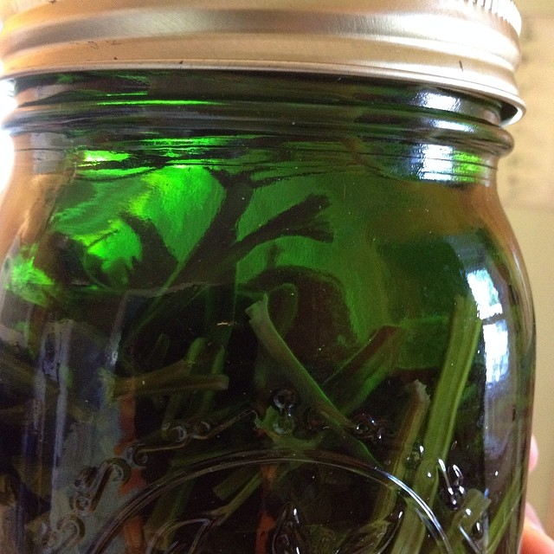
In all cases, make sure the plants are chopped small so that you have a good ratio of herb to solvent, and keep the plant matter submerged at all times – if necessary you can weight it with a clean stone or smaller jar (be careful when shaking in this case).

When the tincture is finished macerating, pour it through a strainer, cheesecloth, and/or jelly bag and funnel into a clean jar. I do recommend using cloth of some sort so that you can gather it up and squeeze the heck out of the marc to get every possible drop of tincture into your bottle – this is valuable stuff. Tip: Keep your hands below your elbows and over the funnel or the liquid will run everywhere. Tinctures are usually taken in small doses: a few drops to ¼ teaspoon several times a day. Stored properly, they will keep more or less forever.

Liniment
A liniment is exactly the same as a tincture, but intended for topical application. Often, 70% isopropyl (rubbing) alcohol is used for this because it’s cheaper and also more penetrating. You can, however, use any of the alcohols above as well, which are in fact gentler on your body. Be sure to mark “external use only” on the label.

Acetum
The method here is, again, nearly the same as that of making a tincture (this will come up a lot, in fact). The menstruum, in this case, is vinegar. Any vinegar can be used as long as it is at least 5% acetic acid: apple cider, white wine, coconut, balsamic, etc. I recommend avoiding distilled white vinegar – it is made from mysterious odds and ends and, in my opinion, not very tasty anyway. My favorite for medicinal use is organic, unfiltered apple cider vinegar.

Because this is a more food-like preparation and the vinegar itself plays an important role, we want a lower herb-to-solvent ratio than that of tinctures. Your trusty mason jar should be 1/3-1/2 full of dried herbs before filling it to the top with vinegar. If you use fresh herbs (including things like garlic and berries), fill the jar 2/3 – 3/4 full, and be aware that the product may have a shorter shelf life due to the added water content. It helps the extraction process if you warm the vinegar first until it just begins to steam, in which case your acetum will be ready in about two weeks as long as you shake it regularly. Vinegar corrodes metal, so either use a plastic lid, or put a piece of waxed paper between the mouth of the jar and the lid – in this case you may still get a small amount of black stuff around the rim, but it won’t impact the final product.

Vinegar is a somewhat inferior solvent to alcohol when it comes to many “medicinal” components such as alkaloids and resins, but there is nothing better to extract minerals, and it provides numerous health benefits of its own. Generally, this is not something you would use in an acute situation, but rather work into your daily diet and routine. Acetums will keep at least six months out of direct heat and light, and a year in the refrigerator.

Oxymel
Oxymels are a nice blend of the nutritive, digestive-aiding aspects of acetums and the soothing, healing qualities of honey. The sweetness, too, makes them more palatable for many people. Depending on the herbs, they usually go well in marinades and stir-fry and such, but are not as versatile in that regard as acetums. I think a couple of tablespoons stirred into a glass of water is a tasty drink.

The method is the same as an acetum, except that the menstruum is a mixture of vinegar and honey. Various sources call for anywhere between a 1:5 and a 3:1 ratio of vinegar to honey. I prefer to mix them about 50/50; pour them both into a jar and shake until well blended, then add this to your herbs. As always, try to use raw, local honey. For this reason I don’t recommend heating the mixture, but if you do – if it’s chilly and the honey won’t budge, for instance – just be sure to do so gently and as little as possible. Again, use waxed paper or a plastic lid.

Infused Honey
These are as much culinary delight as medicine, but honey’s emollient and antimicrobial nature provides a perfect vehicle for herbs to address digestive and respiratory tract distress. Try thyme honey for chest congestion and persistent cough, or ginger honey for stomach upset.

This is just as simple as it sounds. Fill a jar about halfway with herbs, and top it off with honey. Have a butter knife or chopstick handy to stir things up and release any major air bubbles, but be prepared for this to take a little time. Once the jar is full, put it somewhere fairly warm and invert it once or twice a day for two to four weeks. If you used fresh herbs, the honey will actively pull the water out of them and become noticeably thinner. I suggest you not attempt to strain this through a jelly bag, but stick to a simple strainer. Honey is an excellent preservative, and this will likely keep for a year or two at a relatively cool room temperature. However, especially if you’ve ended up with a watery consistency, you may wish to store it in the refrigerator. If you do notice bubbles developing, you’re on your way to a potent herbal mead!

Syrup
While a syrup can be made from anything non-aromatic (or when you don’t care about losing the aromatics), it’s particularly useful for those plants that require some forceful handling to fully extract. You start with a very strong decoction: approximately two ounces of dried or four ounces of fresh plant material per quart of water. Bring this to a boil, then simmer uncovered until the liquid is reduced by half. Let this cool until you can handle it safely, then strain it into some sort of measuring implement. For every cup of “tea,” add ½ cup of sweetener: honey, maple syrup and/or molasses, depending on taste and the properties you want. This preserves the decoction, and of course adds the qualities of the sweetener. Older recipes call for sugar, and lots of it, but I’ve found this formula to make a syrup that is plenty sweet and keeps well. If you like, you can add to this 1/8-1/4 cup of brandy to aid preservation and, particularly in the case of cough syrup, act as an antispasmodic.

Syrups are usually taken by the spoonful for medicinal purposes, anywhere from every hour or two to once or twice a day. Of course, many of them use mild food-like herbs and can be liberally applied to yogurt, drinks, pancakes, etc. They should spend most of their time in the refrigerator, and will keep for a good six months.

Note: speaking of cough syrup, one of the best and best-known herbs for this is wild cherry bark, which should never be heated as that destroys its medicinal properties. Instead, use the same ratio listed above, but let it sit in cold or room-temperature water overnight before straining.

Oil
This works on the same theory as a tincture, with the obvious difference of solvent. While alcohol extracts some lipid-soluble factors, you will of course get much more of these with an oil, and essentially none of the water-soluble components.

You will once again fill your jar partway with plant matter, then cover it completely with your oil of choice. For medicinal purposes I’ve found olive oil to be the best and most stable. Coconut and castor oils are also good, but their consistency can pose some difficulties. If your oil is intended for massage, perfume, or cosmetic use, you may want to go with something lighter such as almond or sunflower. I also always add a pinch of slippery elm bark to the jar; it has an historical use – which I have yet to see disproven – of preventing rancidity. Just bear in mind that elm populations are still in a period of slow recovery, and use judiciously.

I highly recommend using dried herbs to make your oils, especially as a beginner. I have had too many batches of fresh-herb oils mold on me. If you do use fresh or fresh-wilted herbs, be sure to use the heat method and allow adequate time (i.e. at least a week) for any leftover water to separate out before the final bottling.

The heat method consists of keeping the oil and herb mixture uncovered (or covered with something permeable like cheesecloth) in a water bath that stays at a steady low heat for several days. 95˚ – 100˚F is ideal; much hotter and you’ll cook the herbs, plus risk spoilage of the oil. A crock pot or rice cooker on the “warm” setting works well for this, if you have one. Place a folded cloth or a canning ring beneath the jar to provide separation from the heating element. On the other hand, I have heard of people using up to 150˚F and claiming to get just as good results, so if all you have is a stove, go with the double boiler method and just do the best you can. The oil is done when it smells strongly of the herbs.

I sometimes use heat with my dried herbs as well, simply because it’s faster and more reliable, but I think the solar method is much more fun. For this, all you do is fill your jar as noted, cap it tightly, and set it in the sun for approximately a month. My only qualm with this method is that, as you know, we rarely get a month of consistently strong sunlight. Without that, it’s unlikely the temperature in the jar will stay high enough long enough to extract much medicine. As a compromise, you can keep it above the stove or in another warmer-than-average place for a few weeks. Try it and see how it works.

When your extraction is finished, again, pour it all through a strainer of some sort and into a bottle. I usually just use the back of a spoon to press it out. Loose-weave cheesecloth is fine as well, though messy, but I find that the thickness of most oils makes it impossible to squeeze out through a jelly bag in the same manner as a tincture. The type of oil you use will largely determine the shelf life, but stored properly most of them should last at least eight months to a year.

Salve
Salves are good for topical application of many herbs, and unlike creams, are extremely easy to make. All you need to do is mix one (or several) of your herbal oils with a little beeswax, which is an extremely healing substance in and of itself. The beeswax actually acts to pull the oil down into the skin and muscle, increasing the salve’s effectiveness (and, incidentally, reducing the oily slick on your skin).

Again, you’ll want to use a double boiler of some sort. Because the wax melts at a higher temperature than you ideally want your oils to reach, I prefer to heat it by itself until it has liquefied, then add in the oil while stirring – it will temporarily resolidify; keep stirring and it will be fine. Once everything is nicely mixed, remove it from the heat. This is a good time to do the spoon test (see below). Add in any essential oils you may be using, give it another stir, and pour it into your containers. Leave these undisturbed overnight or until they’ve set.

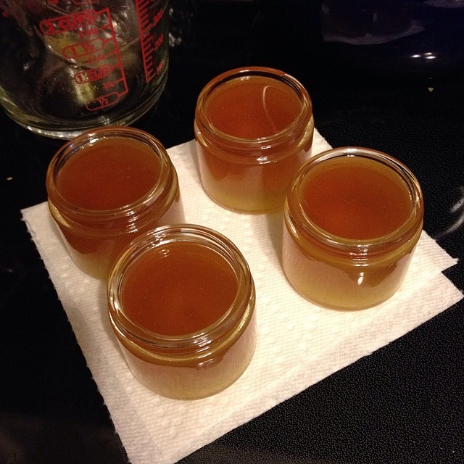
The ratio of oil to wax is a matter of some debate; in my experience, a good place to start is just under one ounce of beeswax to one cup of oil. The standard method for fine-tuning the mixture is called the spoon test: when your salve is mixed but still hot, dip a spoon in to coat it, then place it in the fridge until it’s at about room temperature. If it’s too hard, add more oil; too soft, add more wax. My problem with this method is that it’s very hard to hit that magic temperature on the swift ride from 120 degrees to 36. I prefer to leave it at actual room temperature for 5 or 10 minutes and test it then. Granted, your big batch of salve may start to harden during this time, but it’s easy to re-melt it at this stage.

While it’s not ideal, salves can be melted and remixed even after everything has cooled and set. Just bear in mind eventually some components – especially essential oils - may begin to break down or burn off and lose some effectiveness. Properly stored, they will keep 2- 3 years.

Other preparations
- Eat them! – Fresh, dried, sautéed, sprinkled on other food, etc.
- Infused wine – Like a weak tincture, often including fruits and a dash of fortified wine. Rarely used these days.
- Elixir – Herbs extracted in a mixture of alcohol (usually brandy) and honey.
- Beer – Medicinal properties of most herbs – not just hops - come through the fermentation process quite well.
- Candies – powdered herbs mixed with nut butters, ground oats, sweeteners, chocolate chips, and whatever else gets people to eat them.
- Electuary – Powdered herbs mixed into honey.
- Pill – Powdered herbs mixed with water, tinctures, and/or sweetener, plus a thickener, then dried.
- Capsule - Powdered herbs packed into gelatin capsules.
- Cream – a stable emulsion of oil-based and water-based components, often including waxes and/or butters.
- Poultice – plant material mashed with hot water (or more extemporaneously, spit) into a paste and applied topically.
- Fomentation – A cloth soaked in herbal tea and applied topically.
- Bath – An herbal tea that you sit in (though hand and foot baths are effective as well).
- Steam – A strong, steaming aromatic tea, the vapors of which are inhaled deeply.

Questions?
Sarah17.williams@gmail.com

